Lab Report No 7

Implementation of Edge Detection
Digital Image Processing



Submitted By:
[Huzaifa Shahbaz]
[21-CE-009]
[Aqsa Shah]
[21-CE-039]

Submitted to:
Engr. Hareem Khan
Dated:
15thNov,2024

Department of Computer Engineering,
HITEC University, Taxila
Lab Example No 1:

Solution:
Brief description (3-5 lines)
Sobel filter:
Sobel filter calculates the first order derivative of the image. Horizontal Sobel filter is used to find out the edges along x-axis as it calculates the derivative of an image in x direction while Vertical Sobel filter is used to find out the edges along y-axis. The edges obtained from applying both this filters can then be added to obtain all the edges in an image.
The code
import cv2
import numpy as np
import matplotlib.pyplot as plt
# Load the image
image_path = 'flower.jpg' # Replace with your image path
image = cv2.imread(image_path)
# Convert to grayscale
gray_image = cv2.cvtColor(image, cv2.COLOR_BGR2GRAY)
# Apply Gaussian smoothing (optional)
blurred_image = cv2.GaussianBlur(gray_image, (3, 3), 0)
# Sobel operators
Gx = cv2.Sobel(blurred_image, cv2.CV_64F, 1, 0, ksize=3)
Gy = cv2.Sobel(blurred_image, cv2.CV_64F, 0, 1, ksize=3)
# Gradient magnitude
G = np.sqrt(Gx**2 + Gy**2)
# Normalize to range 0-255
Gx = np.uint8(255 * np.abs(Gx) / np.max(Gx))
Gy = np.uint8(255 * np.abs(Gy) / np.max(Gy))
G = np.uint8(255 * G / np.max(G))
# Display the results
plt.figure(figsize=(15, 10))
# Original image
plt.subplot(2, 2, 1)
plt.imshow(cv2.cvtColor(image, cv2.COLOR_BGR2RGB))
plt.title('Original Image')
plt.axis('off')
# Gradient in X direction
plt.subplot(2, 2, 2)
plt.imshow(Gx, cmap='gray')
plt.title('Gradient in X direction')
plt.axis('off')
# Gradient in Y direction
plt.subplot(2, 2, 3)
plt.imshow(Gy, cmap='gray')
plt.title('Gradient in Y direction')
plt.axis('off')
# Edge-detected image
plt.subplot(2, 2, 4)
plt.imshow(G, cmap='gray')
plt.title('Sobel Edge Detection')
plt.axis('off')
plt.show()
The results (Screenshot)
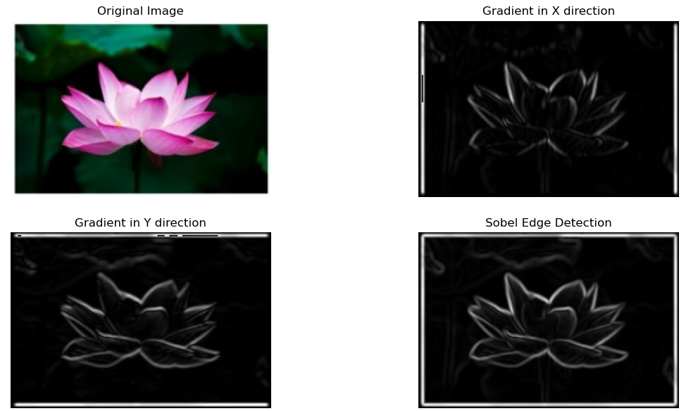
Lab Example No 2:

Solution:
Brief description (3-5 lines)
Laplacian Filter:
Calculates the second derivative of the image to emphasize edges.
Unsharp Masking:
A technique where a blurred version of the image is subtracted from
the original.
The code
import cv2
import numpy as np
import matplotlib.pyplot as plt
# Load the image
image_path = 'flower.jpg' # Replace with your image path
image = cv2.imread(image_path)
# Apply Laplacian Filter
laplacian_filter = cv2.Laplacian(image, cv2.CV_64F)
laplacian_filter = cv2.convertScaleAbs(laplacian_filter) # Convert to 8-bit
# Unsharp Masking
gaussian_blur = cv2.GaussianBlur(image, (5, 5), sigmaX=1)
unsharp_image = cv2.addWeighted(image, 1.5, gaussian_blur, -0.5, 0)
# Display Results
plt.figure(figsize=(12, 5))
plt.subplot(1, 3, 1)
plt.imshow(image, cmap='gray')
plt.title('Original Image')
plt.axis('off')
plt.subplot(1, 3, 2)
plt.imshow(laplacian_filter, cmap='gray')
plt.title('Laplacian Filter')
plt.axis('off')
plt.subplot(1, 3, 3)
plt.imshow(unsharp_image, cmap='gray')
plt.title('Unsharp Masking')
plt.axis('off')
plt.tight_layout()
plt.show()
The results (Screenshot)
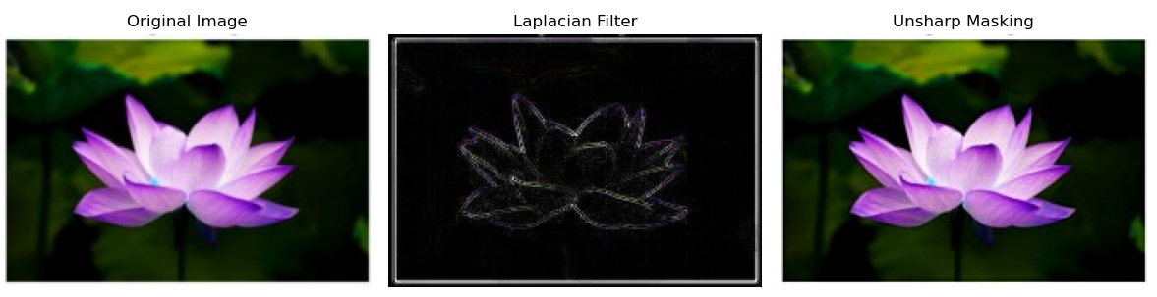
Lab Example No 3(a):

Solution:
Brief description (3-5 lines)
Canny Edge Detection:
Canny Algorithm is known for its optimal edge detection capabilities. The algorithm follows a series of steps to reduce noise, detect edges, and improve the accuracy of edge detection.
The code
import cv2
import numpy as np
import matplotlib.pyplot as plt
# Load the image
image_path = 'flower.jpg' # Replace with your image path
image = cv2.imread(image_path, cv2.IMREAD_COLOR)
gray_image = cv2.cvtColor(image, cv2.COLOR_BGR2GRAY)
# Apply Gaussian blur to reduce noise
blurred_image = cv2.GaussianBlur(gray_image, (5, 5), 1.4)
# Apply Canny edge detector
edges = cv2.Canny(blurred_image, 100, 200)
# Display the result
plt.figure(figsize=(10, 5))
# Original image
plt.subplot(1, 2, 1)
plt.imshow(cv2.cvtColor(image, cv2.COLOR_BGR2RGB))
plt.title('Original Image')
plt.axis('off')
# Edge-detected image
plt.subplot(1, 2, 2)
plt.imshow(edges, cmap='gray')
plt.title('Canny Edge Detection')
plt.axis('off')
plt.show()
The results (Screenshot)
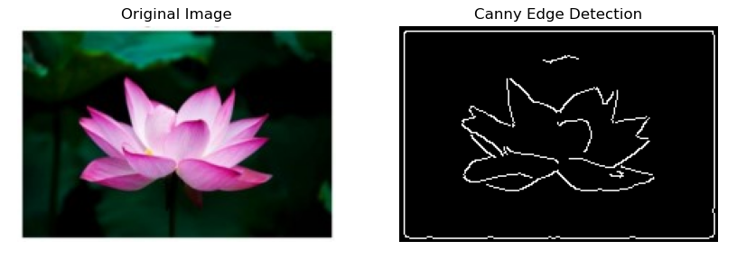
Lab Task#1:

Solution:
Brief description (3-5 lines)
Apply different edge detection techniques on the above given image and plot result.
The code
import cv2
import numpy as np
import matplotlib.pyplot as plt
# Load the image
image = cv2.imread('flower.jpg', cv2.IMREAD_GRAYSCALE)
# Sobel Edge Detection
sobel_x = cv2.Sobel(image, cv2.CV_64F, 1, 0, ksize=3)
sobel_y = cv2.Sobel(image, cv2.CV_64F, 0, 1, ksize=3)
sobel = cv2.magnitude(sobel_x, sobel_y)
# Canny Edge Detection
canny = cv2.Canny(image, 100, 200)
# Laplacian Edge Detection
laplacian = cv2.Laplacian(image, cv2.CV_64F)
# Prewitt Edge Detection
kernelx = np.array([[1, 0, -1], [1, 0, -1], [1, 0, -1]])
kernely = np.array([[1, 1, 1], [0, 0, 0], [-1, -1, -1]])
prewitt_x = cv2.filter2D(image, -1, kernelx)
prewitt_y = cv2.filter2D(image, -1, kernely)
prewitt = cv2.magnitude(prewitt_x.astype(np.float64), prewitt_y.astype(np.float64))
# Display the results
plt.figure(figsize=(12, 8))
plt.subplot(231), plt.imshow(image, cmap='gray'), plt.title('Original Image')
plt.axis('off')
plt.subplot(232), plt.imshow(sobel, cmap='gray'), plt.title('Sobel Edge Detection')
plt.axis('off')
plt.subplot(233), plt.imshow(canny, cmap='gray'), plt.title('Canny Edge Detection')
plt.axis('off')
plt.subplot(234), plt.imshow(laplacian, cmap='gray'), plt.title('Laplacian Edge Detection')
plt.axis('off')
plt.subplot(235), plt.imshow(prewitt, cmap='gray'), plt.title('Prewitt Edge Detection')
plt.axis('off')
plt.tight_layout()
plt.show()
The results (Screenshot)
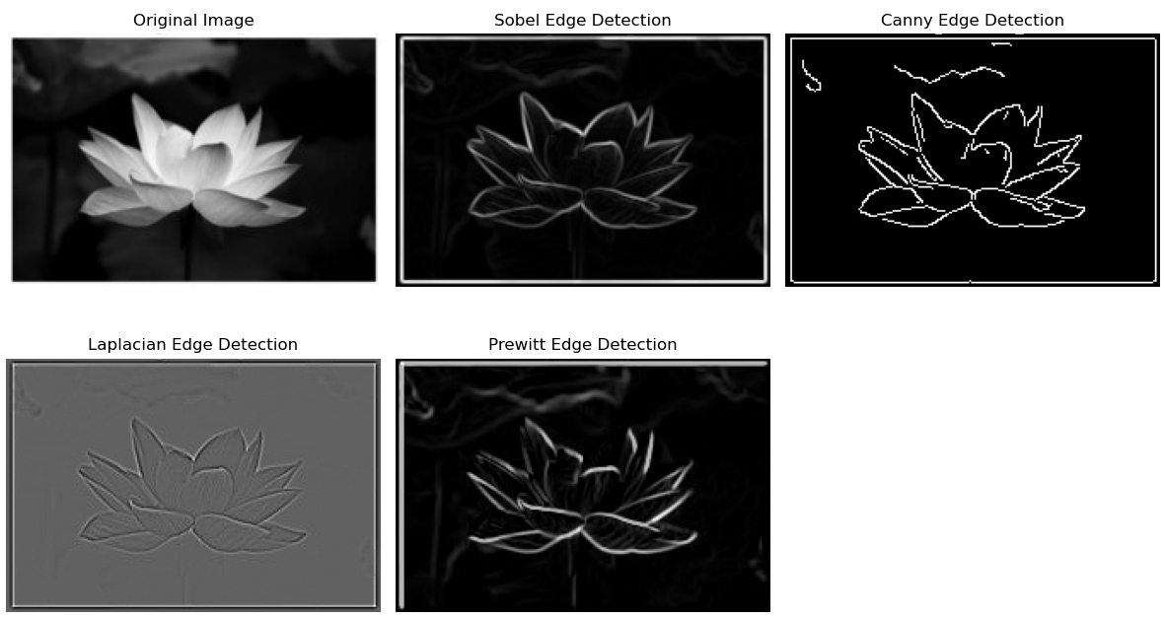
Conclusion
In conclusion, Edge detection is a crucial aspect of computer vision, enabling the identification of object boundaries within images, facilitating image analysis and feature extraction. Algorithms like Sobel, Prewitt, and Canny enhance details while reducing noise. Their effectiveness lies in highlighting high-intensity changes, defining edges. Successful edge detection aids in object recognition and tracking, making it an essential step in image processing, enhancing accuracy and efficiency.

